[Date]

Microsoft account

[company name]

[Document title]

[Document subtitle]

# Introduction

This report is going to demonstrate something

# High-Level Design

## Software Architecture

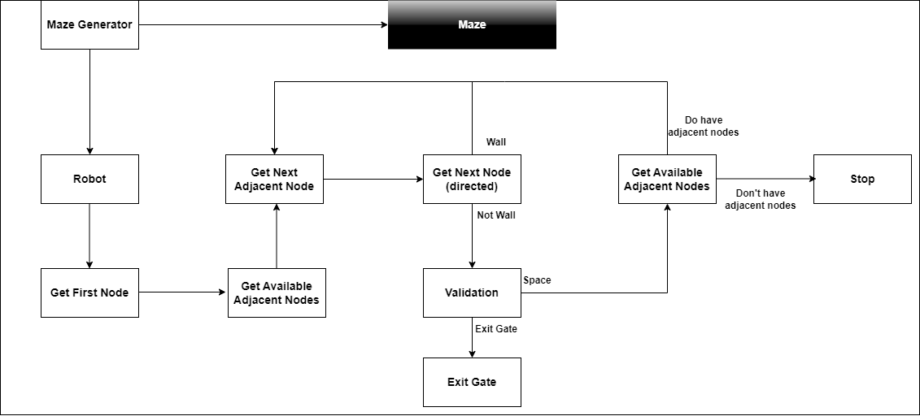

## Class Diagram

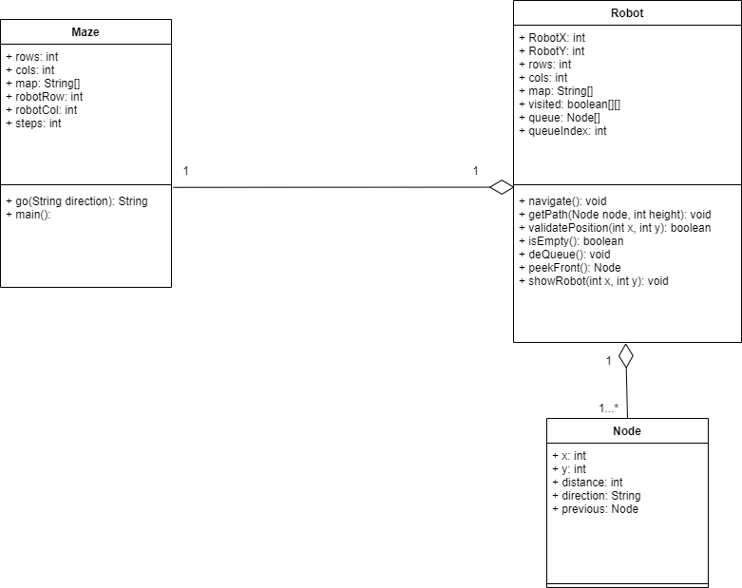

# Data Structure

# Algorithm

# Complexity Analysis

# Evaluation